**Project Report**

on

**HOME AUTOMATION**

In Partial Fulfillment for the Award of the Diploma

In

ELECTRICAL & ELECTRONICS ENGINEERING

**Submitted by:**

BHARGAVA.S 476EE18011

CHETHAN M GOWDA 476EE18013

SURAJ MUKHERJEE 476EE18043

MANJUNATH.R 476EE18022

NITHIN.M 476EE18027

**Guided by:**

**Amulya Rao**

Lecturer

Dept.EE



RAMAIAH POLYTECHNIC

MSRIT CAMPUS,

MATTIKERE,

BANGLORE - 560054

**CONTENT**

* ABSTRACT
* INTRODUCTION..................................... (1)
* BLOCK DIAGRAM......................................... (2)
* COMPONENTS...................................... (3)
* ADVANTAGES…………………………………………….. (4)
* DISADVANTAGES …………………………… (5)
* FUTURE SCOPE ………………………………………..

**ABSTRACT**

The project that we are presenting is about home automation. The concept of this is making our daily chores easier by using the technology. Our project is about controlling the home appliances in a smart way by using our phones to control the devices. This device makes the working and controlling of the home devices in more efficient way. This device manages the power consumption of the appliances.

**INTRODUCTION**

**Home automation** is building automation for a home. A home automation system will monitor and control home attributes such as lighting, entertainment systems, and appliances.

It also includes home security such as access control and alarm systems. Home devices are an important constituent of the Internet of Things.

Such systems depend on the collection of data. The data is then used for monitoring, controlling and transferring information to other devices via the internet. This allows specific actions to be automatically activated whenever certain situations arise.

Now apply the same concept to the entire home and all the devices present. That is a smart home powered by IoT. Instead of manually going up to the device and taking action, those actions can be taken at the press of a button. **These days, most smart IoT home automation devices allow you to control them via an app or even via voice commands.**

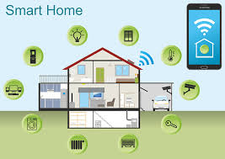

Page 1

**BLOCK DIAGRAM**

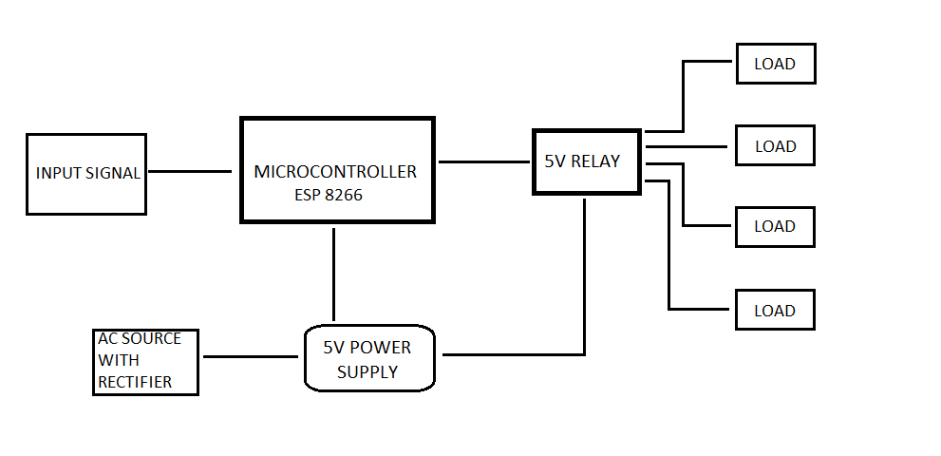

Page 2

**COMPONENTS**

**HARDWARE**

* MICROCONTROLLER(ESP 8266)
* RELAY MODULES 5V
* 5V POWER SUPPLY BOARD
* RECTIFIER CIRCUIT
* DC TO DC CONVERTERS
* MOBILE PHONE
* INTERNET CONNECTION
* AC LOADS

**SOFTWARE**

* ARDUINO IDE

Page 3

**ADVANTAGES**

* **Managing all of your home device from one place**
* **Flexibility for new devices and appliances**
* **Maximizing home security**
* **Remote control of home functions**
* **Increased energy efficiency**
* **Improved appliance functionality**
* **Home management insights**

Page 4

**DISADVANTAGES**

* Initial cost is more
* Maintenance
* Data transmission speed is less

Page 5

**FUTURE SCOPE**

Future scope for the home automation systems involves making homes even smarter. The system can be integrated closely with home security solutions to allow greater control and safety for home owners. The next step would be to extend this system to automate a large scale environment, such as offices and factories.